**Cluster IP service:**

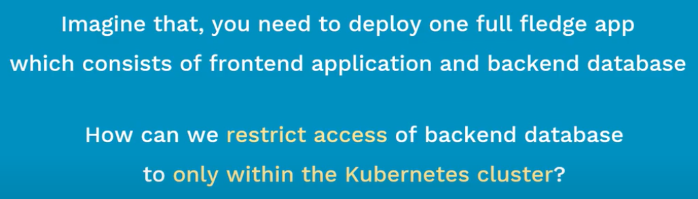

* Cluster IP is the default type in service.
* It will be useful for the connection between pods which are not required to be exposed to internet.

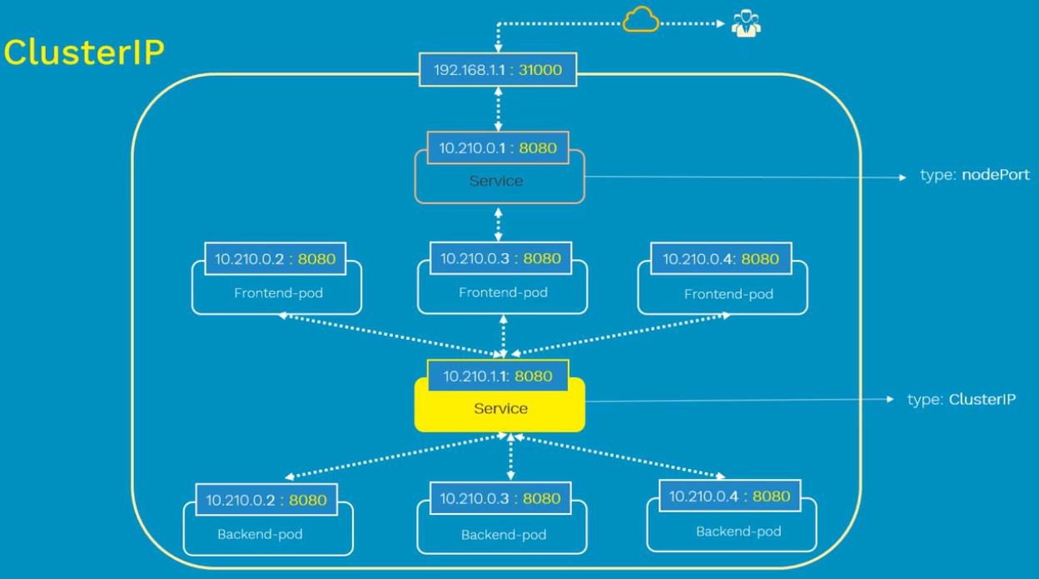

**Deploying test application:**

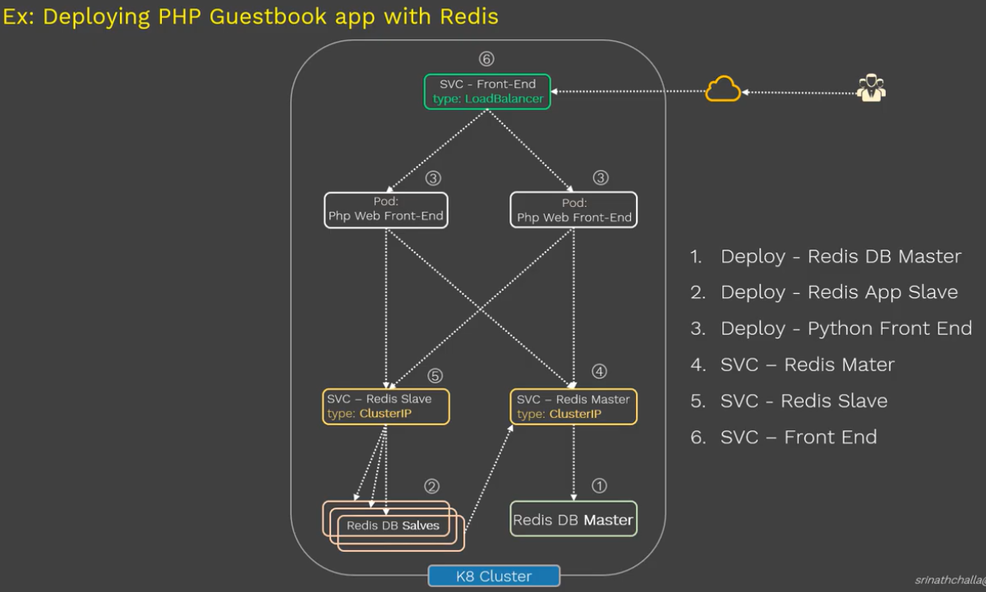

As below, we are deploying the redis master in cluster.

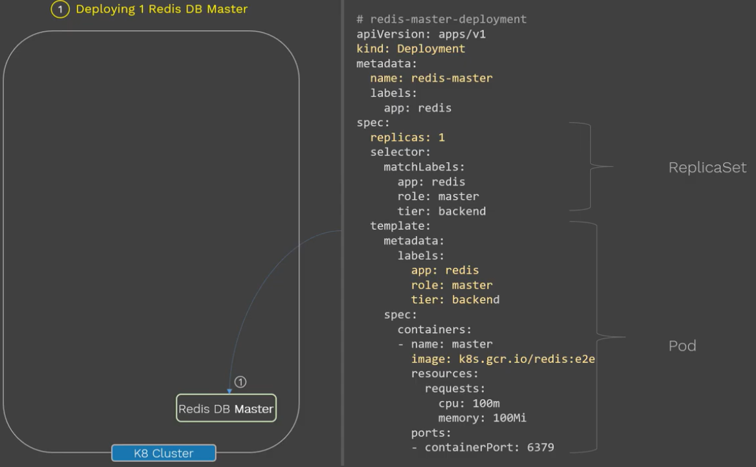

As below, we can deploy the redis slaves.

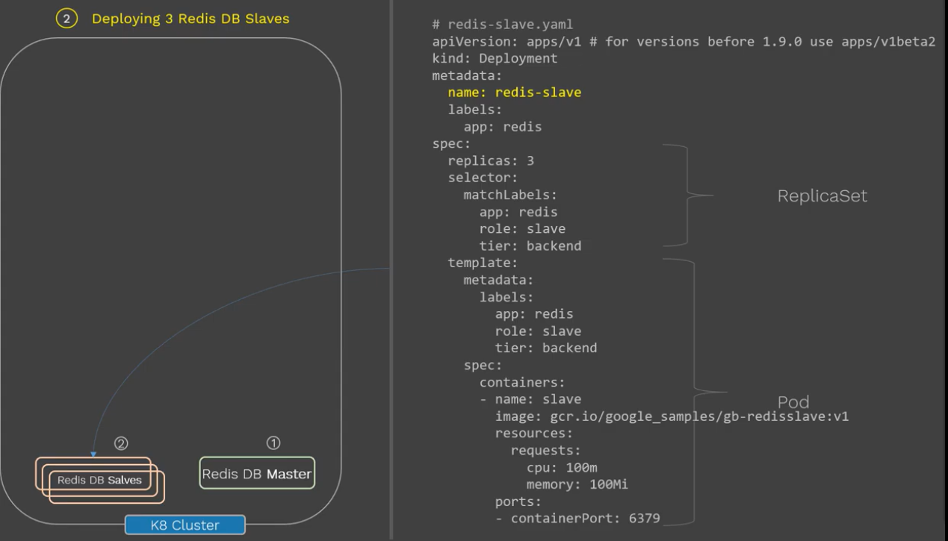

Now, the backend DBs are ready. We can deploy frontend apps as below.

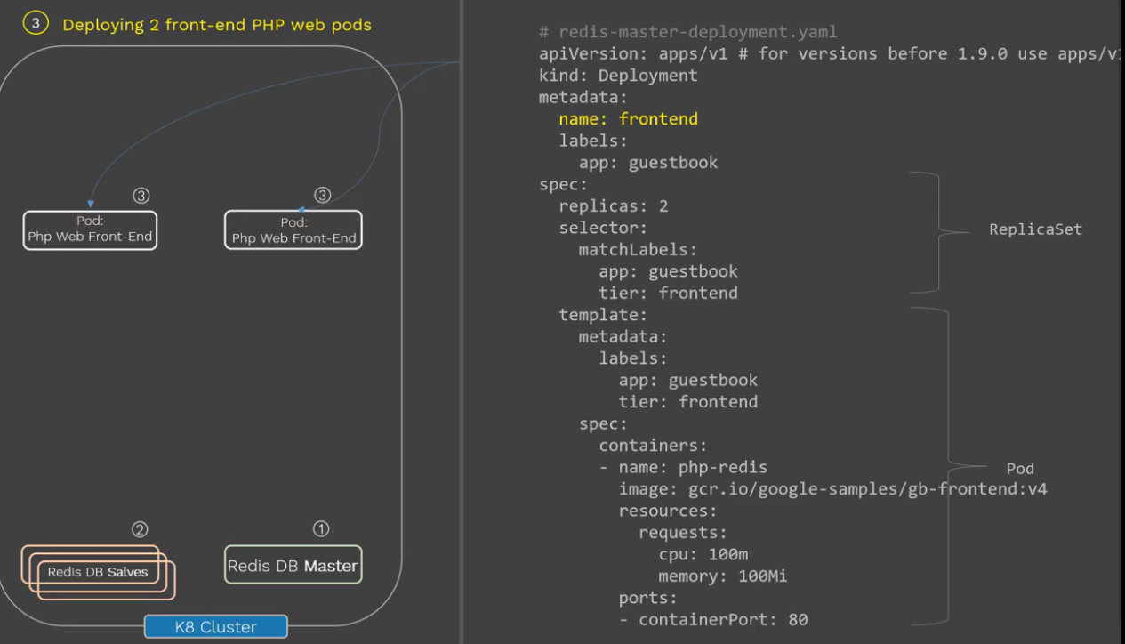

* As for now, we created the required pods in part 1. Now, we need to create the service for the internal connections between frontend and redis. Also, we need to create a service to expose the frontend to outside world.

**Part 2 – services:**

**Redis master service:**

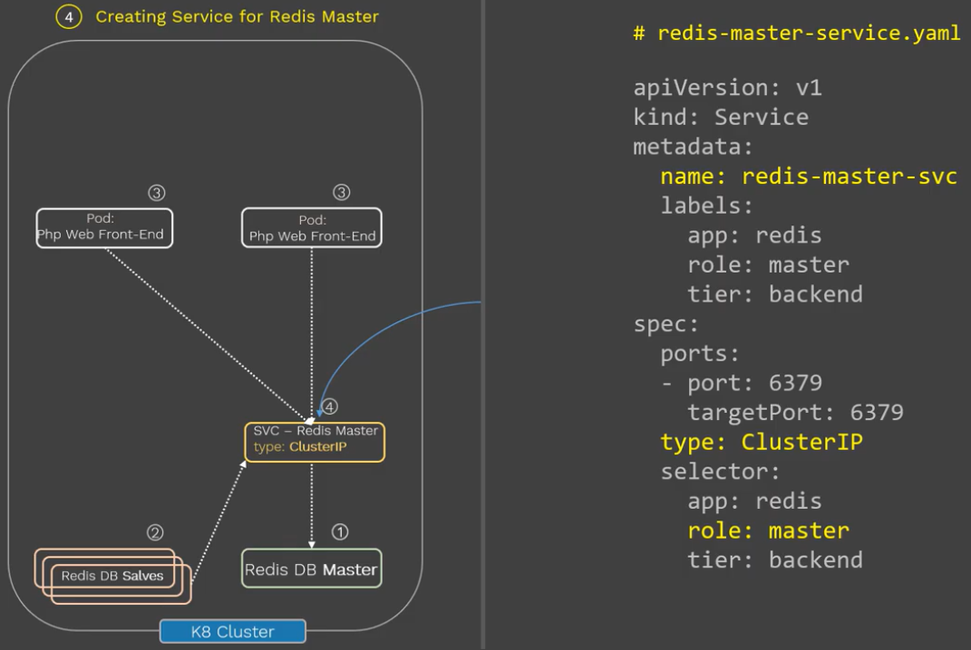

* Once this is created, the pods will be connected to this service and this service will detect the redis master based on the labels.

**Redis slaves service:**

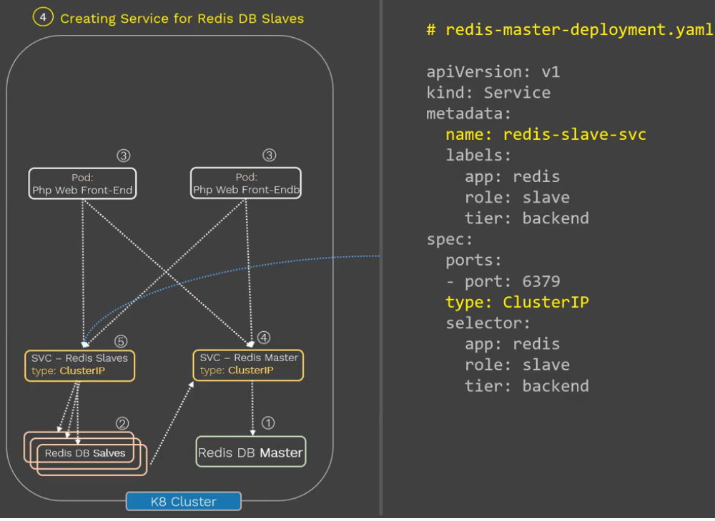

**Service for frontend pod:**

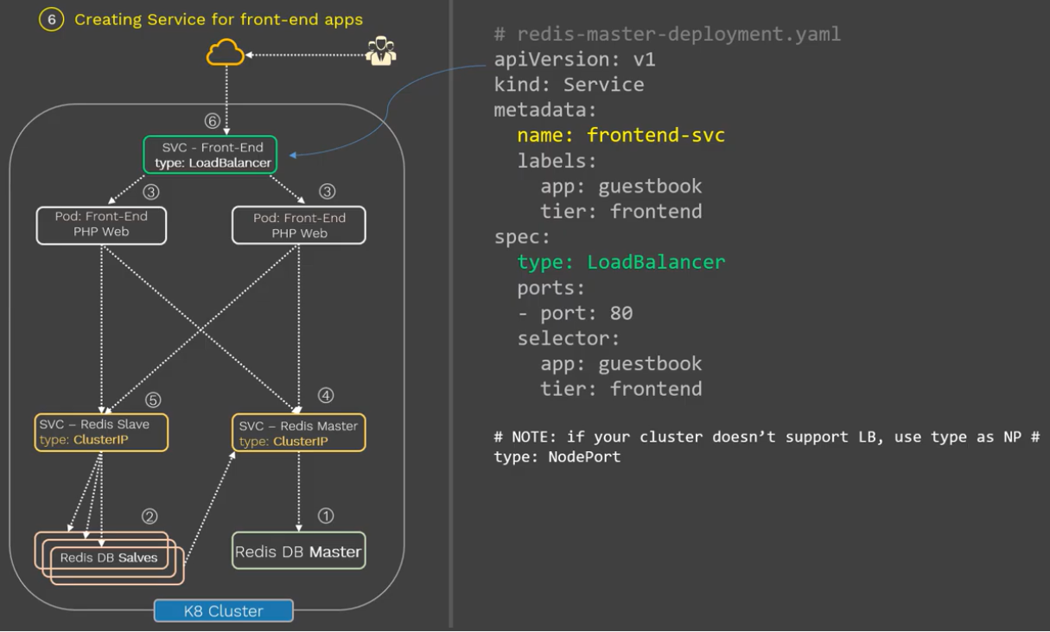

**Display:**

